NATIVE JAMES WELCOMES YOU TO THE REALM…
BRAND NEW EP CONFESSIONS OF A SINNER
OUT TODAY - LISTEN HERE
EMBARKS ON FIRST EVER UK HEADLINE TOUR IN NOVEMBER - BUY TICKETS HERE

Credit: Cameron Dickson
Press assets here

Metal/grime artist Native James welcomes you to the realm… he today releases his long-awaited EP, CONFESSIONS OF A SINNER. The accomplished body of work is a follow up to last years Rebirth EP, and is a huge step up for the rising star. The EP features the previously released singles FALLEN, which marked the start of this new alluring chapter, GTFU and YOU’RE NOTHING, alongside three unheard tracks including PRY AWAY. All of these songs are weaved in seamlessly between cinematic interludes, which sees Native in a different light and proves that he is always evolving his style.
On PRY AWAY, Native has said, “I wanted to peel the scars off and show wounds with this song. It’s about the internal struggles of mental health, addiction, being comfortable with talking about what is wrong with us, and us going back to the dark place out of habit.”

Native has also commented, "This EP is ups and downs, trials and tribulations; it entices the duality of oneself while taking you down a path of reflection. It's connected with rage and all the above - a sinner and his thoughts.”

2025 has been monumental for Native James. It has seen him nominated in the Best Alternative Act category at the MOBOs, play his first ever Glastonbury where he played not one, but two sets and support Letlive. at their two farewell London shows, to name just a few wins. His releases have gained continued support from the likes of BBC Radio One’s Alyx Holcombe, on DSPs including on Spotify where Native graced the cover of playlist Misfits 2.0, and even landed his track Power on a Co Op advert.

Showing no signs of slowing down, Native is gearing up for his first ever UK headline tour next month! To celebrate the release of CONFESSIONS OF A SINNER, the Ipswich-based artist will kick off the live dates at Anarchy Brew Co on 3rd November, and make his way around Manchester, Norwich, Southampton and Bristol, before wrapping things up at London’s Old Blue Last on 12th November. Full dates, details and tickets can be found here.

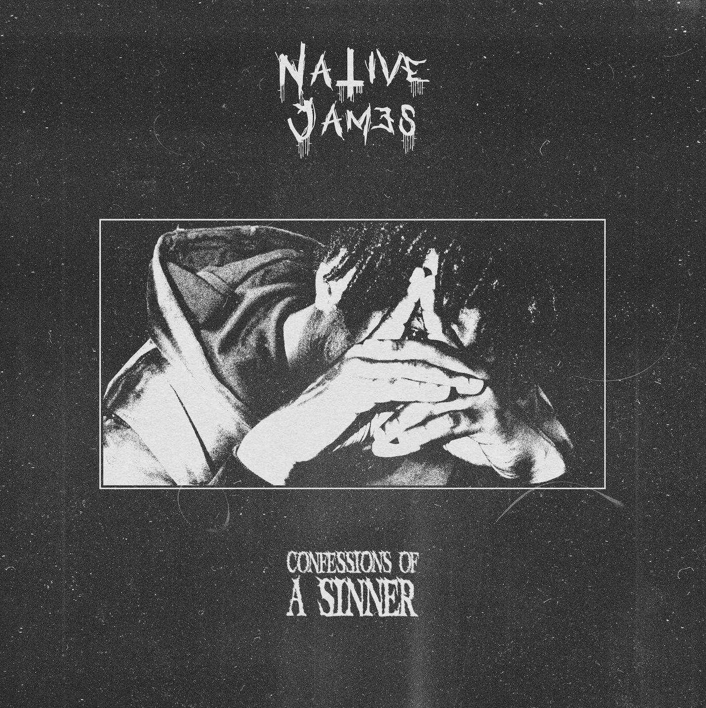

Catch Native James live:

3.11 - Anarchy Brew Co, Newcastle*
4.11 - The Lodge, Manchester*
5.11 - The Waterfront Studio, Norwich*
8.11 - Nice As Pie Race - Wharf Chambers, Leeds
9.11 - Suburbia, Southampton*
11.11 - Exchange, Bristol* (LOW TICKETS)
12.11 - Old Blue Last, London* (LOW TICKETS)

*Headline tour dates

Follow Native:
Instagram
Spotify
YouTube
TikTok

For all press enquiries please contact michelle@halestormpr.com

